Isaac
Did you write any Shaun? Anything you wanna roll with? shaun.theiring.283@my.csun.edu

Which early engagement and content characteristics are associated with algorithmic amplification among low-authority creators on TikTok?
What features distinguish TikTok posts from low-authority creators that achieve high algorithmic reach?

Model: (Y) - linear regression to measure algorithmic amplification with; algorythmic_amplification_index and/or reach
(X) -early engagement, authority, content_type, post_format

hypothesis : authority is low, what early signals and content attributes matter

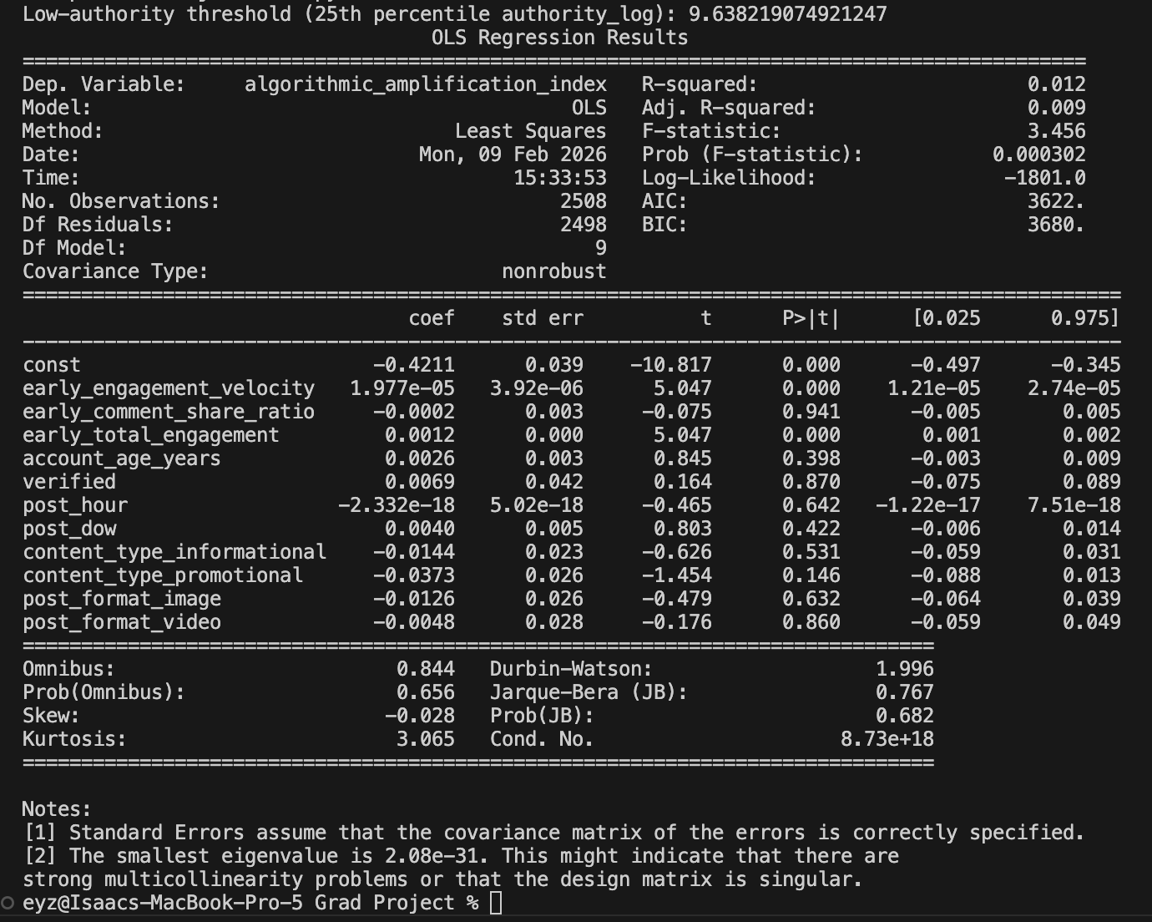

Among low authority creators, early engagement dynamics, not content features are primary differentiators of algo amplification

Early engagement velocity is positive and highly significant
Early total engagement is positive and highly significant

Content category and format don’t matter among low authority creators

Meaning content quality may matter indirectly through engagement

R squared is .0012 algorithmic system is noisy, many unobserved factors and restricted to low_authority creators

Some early engagement variables are correlated and expected; velocity and total engagement

Adjustments: reduce model keep velocity and drop total engagement

If you predict you need control

1. Are people more influenced by who shares a product or how they talk about it?
Does big influencer generate better results
2. When a brand is promoted by an entertaining influencer, does the brand get ignored
a. Is entertainment stealing attention from persuasion? People remember the joke but not the brand
b. Do influencers entertain more than they persuade?
3. Do consumers perceive brand differently if marketing message is pushed instead of being exposed naturally in the feed
a. Is exposure intensity negatively impacting the persuasion
b. Does over exposure result in reduced consumer interest
c.
4. Under what condition do small creators outperform bigger influencers
a. Does manipulating or capturing an algorithm pattern result in greater reach
5. At what point does an influencer becomes annoying
6. Are consumers emotionally reacting but not behaviorally engaging? Do consumers react to post to be socially active and get a response from the famous influencer rather than genuinely responding to the post
7. How can a brand make the consumer feel his voice is heard
8. Is early excitement around influencer content more valuable for brands than steady long-term engagement?
9. Do consumers rely more on influencer authority than message quality when engaging with branded content?
a. Do consumers look out for a witty content to be famous on the comment section
10. In what content type gets more textual or opinion based response (informational / experiential / promotional)

Shaun Clarification
Which early engagement and content characteristics are associated with algorithmic amplification among low-authority creators on TikTok?

Do different types of early engagement influence engagement success differently?
- “Early columns” (persuasive powers)

Is there an association between early engagement metrics and total engagement success?

- We could specify further “by influencer authority type”, “by
- Differentiate into specific total engagement success
  - High v low effort engagement

Do we have to define engagement success? Or is this what you mean above based as high and low engagement?
I would just list off the columns associated

There is an x and a y, find the association and most likely empirical

Do early engagement metrics predict total engagement success after accounting for algorithmic amplification?

Make different new features

Length of report time
First post 1/1/24
last post 12/30/25

Funnel analysis

- Is there an association between early engagement metrics and total engagement success?
  - H1: Early engagement metrics will positively predict engagement success
    - MODEL: OLS Regression predicting engagement_success_index from log transformed early_likes, early_comments and early_shares. H1 is supported if the coefficients on early_engagement metrics are positive and statistically significant
  - H2: Early engagement velocity positively predict total engagement success
  - H3: Highly active influencers have different early engagement metrics versus non-active influencers
  - H4: Highly active influencers have higher total_engagement metrics
  - H5: Non-Active influencers have less early likes versus active influencers
    - MODEL: OLS Regression predicting log(1+early_likes) from an Active influencer Index (1= Active, 0= Non-Active). H5 is supported if the coefficient on the active variable is positive and statistically significant, indicating that active influencers receive more early likes than non-active influencers
  - Feature Engineering:
    - Influencers in the the top 20% of created post (20) for the window for the period of the data = highly active influencer
- Does early audience engagement reflect sustained audience interest or short-lived engagement spikes?
    - Hypothesis - Does likes_spike_indicator(early_likes / total_likes) reflect sustained audience interest or short-lived engagement spikes?
      - Early- likes spike indicator shows that 70% of the data reflects that likes in the early window show that the post has a short lived spike.
    - hypothesis - top 5% of influencers in the data set shows the opposite, meaning there are early likes but also sustained interest.
    - Post success - individual posts we are taking total_likes/reach. Closer to 1 it is a more successful post.
      - Majority of top 5%(500 post) post have sustained engagement, instead of spikes
      - Histogram - opposite of likes spike indicator
      - Scatterplot-
  - H1: Highly active influencers have higher sustained interest versus non highly active influencers
  - H2: Specific content types have greater sustained engagement
  - H3: There is a correlation between follower count and sustained engagement
  - H4: Less active influencers will have less sustained engagement
    - Model: Logistical Regression predicting the sustained engagement from Active influencer indicator(1= Active, 0= less active). H4 is supported if the coefficient on the active variable is positive and statistically significant, indicating that less active influences are less likely to generate sustained engagement.
  - H5: is sustained engagement associated with high total success metrics
  - Feature Engineering:
    - Top 5% in early engagement and top 5% in total engagement = sustained interest
    - What are the columns you're gonna use for this?
  - Feature Engineering : Top 5% Influencer
    - Top 40 influencers measured by authority_log + impressions per reach + high_effort_engagement
  - Feature engineering: total_engagement
    - total_likes + total_comments + total_shares
- Does influencer post_format strengthen or weaken the relationship between early engagement and overall engagement success?
  - H1: Images have higher early_engagement than videos
  - H2: Videos get more total_comments than carousels.
  - H3: Verified Highly active influencers generate more early_shares
  - H4: does higher time between post generate less followers
  - H5: time between post is lower for a verified users
  - Feature:
    - time between post - average time difference between and two post for an individual influencer
- Is there an association between influencer type and high level engagement conversion?
  - H1: Hot influencers have higher early_engagement_velocity
  - H2: Dead Beat have lower early_total_engagement
  - H3: Informational content_type has higher engagement_success for Dead Beat influencers
  - H4: Hot influencers receive higher algorithmic amplification than Dead Beat influencers
  - H5: The relationship between amplification and engagement success is stronger for Hot influencers than for Dead Beat influencers.
  - Features:
    - “Dead beat” influencer: long account tenure with lower follower counts, Hot influencer: short account tenure with higher follower counts
- Do different influencer types get amplified differently even with similar early engagement?
  - H1: Different times of the year are associated with different early engagement metrics
  - H2: High post frequency is correlated with higher sustained engagement
  - H3: higher Post frequency leads to better algorithmic amplification
  - H4: promotional focused influencers get amplified more than other types of influencers
  - H5: Post frequency has a greater impact of total engagement success than content type
  - Features:
    - Post Frequency: total number of posts by influencer divided by the amount of time in months or days from first post to last post
    - Sustained engagement: from previous question
    - Informational/experiential/promotional focused influencer: based on majority of their post types

Feature Engineering

Construct Mapping

- Sustained engagement (contingent upon the fixed data)
  - Does early audience engagement reflect sustained audience interest or short-lived engagement spikes?
  - Title:
    - From Spike to Sustained: Understanding Temporal Dynamics and Post Success

- Influencer type analysis
  - Are different influencer types correlated with overall engagement success?
  - Title:
    - The role of influencer identity in engagement performance

- Post conversion analysis
  - Do certain posts metrics indicate whether or not a post will generate link clicks/other high engagement metrics
  - Title:
    - From visibility to action: post metrics and conversion outcomes

RQ1:
To what extent do algorithmic amplification index and influencer characteristics jointly predict the expected count of high-effort engagement?
H1: Higher reach is positively associated with high-effort engagement.
- Feature engineering - influencer_score = authority_log + impression per reach + frequency_of_post_per_month +log(reach)
- Y= log(1+ high-effort-engagement) dependent variable
  - Predictors = log(reach) and influence_score
    - Captures structure, exposure scale avoids early metrics from data inconsistencies.
H2: Higher impressions per reach is positively associated with high-effort engagement.
- impressions_per_reach positively predicts high-effort engagement
H3: Greater exposure persistence (longer visibility duration) is positively associated with high-effort engagement.
- exposure_persistent_hours positively predicts high-effort engagement
H4: Higher influencer authority (authority_log) is positively associated with high-effort engagement outcomes.
- Authority log
H5: Higher posting frequency is positively associated with high-effort engagement.

RQ2:
Do influencer characteristics provide incremental explanatory power beyond algorithmic amplification in predicting high-effort engagement?

RQ3:
Which predictor exhibits a stronger association with high-effort engagement when modeled simultaneously, algorithmic amplification or influencer characteristics?

Issues:
- Early comments are more than total comments ID 433 inconsistencies
- ⅔ of data have same number of early likes and total likes
- Early Shares are an issue too

3/2

RQs

RQ1:
To what extent do algorithmic amplification index and influencer characteristics jointly predict the expected count of high-effort engagement?
Model: Influencer
Rationale: High effort engagement is a behavioral outcome that reflects meaningful audience interaction versus low effort engagement that is very passive. We think that high effort is driven by two forces
- Algorithmic amplification: platform driven distribution mechanisms that increase exposure.
- Influencer characteristics: creator driven traits authority log and posting frequency that reflect structural capacity to targeted audiences.
By testing them jointly we can assess which engagement is primarily a function of platform amplification, influencer attributes or a combination of both.
A dependent variable is non-negative integer valued that is extremely right skewed (13+) and severely overdispersed with variance being over 76 times greater than the mean; we can't use OLS as it would violate assumptions. We will use a negative binomial regression model as it looks at the expected count of engagement while accounting for overdispersion.
What Must Be Finalized Before Estimation
Proper construction of the influencer score:
- Log-transform posting frequency using log(1 + frequency).
- Standardize authority_log and log-frequency before summing.
Confirm no severe multicollinearity between amplification and influencer score.
Ensure no missingness distorts model comparison.

RQ2:
Do influencer characteristics provide incremental explanatory power beyond algorithmic amplification in predicting high-effort engagement?
While RQ1 tests joint influence, it does not clarify whether influencer characteristics contribute unique predictive power beyond amplification.
Algorithmic amplification may already incorporate reach-based advantages, potentially absorbing much of the variation in engagement. This question isolates whether influencer-level structural traits add explanatory value above and beyond platform-driven exposure.
Methodologically, this is tested using a hierarchical comparison:
Model 2: High-effort engagement ~ Amplification Index
Model 3: High-effort engagement ~ Amplification Index + Influencer Score
A likelihood ratio test and comparison of AIC values determine whether adding influencer characteristics significantly improves model fit.
This directly evaluates incremental contribution.

What Must Be Finalized Before Estimation
- Ensure influencer score does not mechanically overlap with amplification metrics (avoid conceptual redundancy).
- Confirm influencer score excludes reach (as reach is already embedded in the amplification index).
- Verify that the composite index is constructed consistently and theoretically justified.

RQ3:
Which predictor exhibits a stronger association with high-effort engagement when modeled simultaneously, algorithmic amplification or influencer characteristics?
Even if both predictors are significant and influencer characteristics add incremental value, their relative strength remains unclear.
This question compares the magnitude of association when both predictors are included in the same Negative Binomial model.
Interpretation will rely on:
- Coefficient size (log count changes)
- Incidence Rate Ratios (IRRs)
- Standardized predictors (if necessary for comparability)
This determines whether high-effort engagement is more strongly associated with:
Structural creator power or Platform-level amplification mechanisms
This distinction is central to the theoretical contribution of the thesis.

What Must Be Finalized Before Estimation
- Consider standardizing both predictor indices before modeling for interpretability.
- Confirm moderate (not high) correlation between amplification and influencer score.
- Report IRRs to make comparative interpretation clearer.

RQ4: To what extent is sustained engagement, associated with higher rates of high-effort user interactions such as link clicks and shares on social media?
- Sustained engagement: characterized by high engagement within the first 60 minutes of a post and strong total engagement levels,
Shaun Title: Sustained Engagement on Social Media: The Relationship Between Early Interaction and High-Effort User Actions
Ameya Title: Influencer Characteristics and Activity Dynamics as Predictors of High-Effort Engagement on Social Media
RQ: To what extent do influencer characteristics and Activity Dynamics

Isaac Title: The Role of Algorithmic Amplification in Driving High-Effort Engagement
RQ: To what extent are algorithmic amplification features associated with high-effort engagement?

